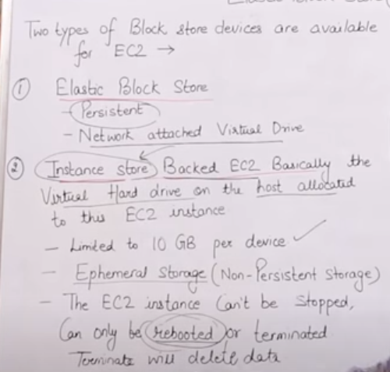

So Instance store storage can be deleted if EC2 is either stopped or terminated, except rebooted. Whereas EBS will not be deleted even if EC2 is stopped, terminated (by default) or rebooted.

